**CHAPTER 1**

**INTRODUCTION**

The world of cakes has just become more exciting with the advent of a new cake ordering application. This application allows customers to create and order their own customized cakes, tailored to their specific preferences and tastes. With a wide range of cake bases, flavors, toppings, and decorations available, the possibilities for creating unique and delicious cakes are endless.

The cake ordering application offers a user-friendly interface, making it easy for customers to navigate and customize their cakes. Users can choose from a range of cake bases, including traditional flavors like vanilla and chocolate, or more unique options like red velvet or lemon. They can also select the size and shape of their cake, whether it **be** a round, square, or rectangle cake.

Once the cake base has been selected, customers can choose from an array of mouth-watering flavors such as strawberry, raspberry, or even matcha. The application offers an extensive list of flavors to choose from, ensuring that every customer can find the perfect match for their taste buds.

The customization options do not end with the cake base and flavor, as the application also offers a variety of toppings and decorations to add that extra personal touch. Customers can choose from fresh fruit, edible flowers, or sprinkles to top off their cake, and even upload their own images or logos to create a truly personalized cake.

Ordering a customized cake has never been easier, with the cake ordering application providing a simple and streamlined process. Customers can select their preferred delivery date and location and track their order status in real-time. The application also ensures the highest quality of ingredients and freshly-baked cakes, ensuring that every cake is both delicious and beautiful.

## MOTIVATION

## There are several motivations for making a cake ordering application where people can customize their own cakes:

## Personalization: Customers appreciate the ability to personalize their cakes to suit their specific tastes and preferences. By offering a wide range of customization options, businesses can create a unique and engaging experience for customers.

## Convenience: A cake ordering application allows customers to order and customize their cakes from the comfort of their own homes, at any time of day or night. This can save them time and effort compared to traditional methods of ordering cakes.

## Increased sales: By offering customization options, businesses can potentially increase their sales by catering to a wider range of customer preferences and needs. Additionally, the convenience of ordering online can attract new customers who may not have otherwise considered the business.

## Competitive advantage: In a crowded market, offering a unique and personalized experience can help a business stand out from its competitors. A cake ordering application that allows customers to customize their own cakes can differentiate a business and potentially attract new customers.

## Overall, a cake ordering application that allows customers to customize their own cakes can offer a range of benefits for both businesses and customers, and can be a valuable tool for growth and success in the modern marketplace.

* 1. **PROBLEM STATEMENT**

The traditional process of ordering a cake for a special occasion can often be a hassle, involving trips to multiple bakeries and limited options for customization. Additionally, in-person ordering may not be feasible for customers who live far away from bakeries or have limited mobility. This can result in a less-than-ideal cake selection and an overall less enjoyable experience for customers.

To address these challenges, the problem statement for a cake ordering application that allows customers to customize their own cakes is as follows:

There is a need for a user-friendly cake ordering application that provides customers with a convenient and enjoyable experience to create and order their own customized cakes. The application should offer a wide range of customization options, including different cake bases, flavors, toppings, and decorations, and provide efficient delivery services to ensure the freshness and quality of the cake.

The application should also offer a simple and streamlined ordering process, allowing customers to easily select their preferred cake design, size, and delivery date and location. Through the development of such an application, customers can have a personalized and hassle-free experience when ordering cakes for special occasions.

* 1. **OBJECTIVE**

The objective of the cake ordering application is to provide a user-friendly and customizable platform for customers to design and order their own personalized cakes. The application aims to offer a wide range of cake bases, flavors, toppings, and decorations to choose from, ensuring that every customer can create a cake that is tailored to their specific tastes and preferences.

One of the primary objectives of the cake ordering application is to provide convenience and ease of use for customers. The application is designed to be user-friendly and intuitive, with a streamlined ordering process that allows customers to easily select their preferred cake base, flavor, and decorations, and place their order with just a few clicks.

Another objective of the cake ordering application is to offer high-quality and freshly-baked cakes made with premium ingredients. The application aims to work with only the best bakeries and cake shops, ensuring that every cake is baked to perfection and uses only the freshest and highest quality ingredients.

The cake ordering application also aims to offer a seamless and efficient delivery service. Customers can select their preferred delivery date and location, and track their order status in real-time, ensuring that their cake is delivered to them in a timely and convenient manner.

Ultimately, the objective of the cake ordering application is to provide customers with a unique and personalized experience when it comes to ordering cakes. By offering a wide range of customization options and a hassle-free ordering process, the application aims to make it easy and enjoyable for customers to create and order their very own customized cake for any occasion.

**CHAPTER 2**

**LITERATURE SURVEY**

## INTRODUCTION

A literature survey, also known as a literature review or a systematic literature review, is a critical and comprehensive evaluation of existing literature on a particular research topic or question.

The purpose of a literature survey is to identify, analyze, and synthesize existing knowledge on a specific topic, with the goal of determining what is known, what is not yet understood, and what areas require further research.

A literature survey involves searching and reviewing a wide range of scholarly sources, such as journal articles, books, conference proceedings, and other relevant publications. The review process typically includes summarizing and evaluating the key findings, methodologies, and limitations of each source, as well as identifying any gaps, inconsistencies, or contradictions in the existing literature.

Overall, a literature survey is an important tool for researchers to gain a comprehensive understanding of the current state of knowledge in their field, to identify potential areas for further research, and to contribute new insights to the existing body of literature.

To fully understand the workflow of a booking system, a thorough review on equivalent systems has been done as a guideline for development of the proposed system and overcoming the weaknesses which present in the existing system. In the work, we have directly review several online booking systems including PlarreBakehouse.com [1], DQCakes.com [2], and BakerDays.com [3].

## LITERATURE SURVEY

**a) Fergusson Plarre Bakehouses Reservation System**

Fergusson Plarre Bakehouses Reservation System [1] consists of several modules such as registration module, user login module, cake customisation module, search module, reservation module, and payment module. Integration of these modules provides a consistent and coherent user experience in customising and purchasing their self-designed cake over the Internet.

The user interface used is simplistic, which avoids clutters, hence allowing users to focus on designing and close the deal. There are several pre-customised cake choices that have been made to make it easy for users to design their own cakes without the need for an expert help.

**b) DQ Cakes Reservation System**

The DQ Cakes Reservation System [2] utilises a simpler working methods which requires users need to fill an online order forms and make payments through the system. Further deal needed to be completed directly with the store. Hence, a lot of modules are eliminated from this system, focusing only to receive an order and payments.

The user interface display provided is limited to listing the nearest branches and cake designs only. Prepared cakes need to be manually received at a store by the residence.

**c) Baker Days Reservation System**

Baker Days Reservation System [3] has several modules including registration module, login module, search module, cake design customisation module, reservation module, and payment module.

The reservation system displays several cake designs based on categories; welcoming celebrations, birthday cakes, corporate cakes, graduation cakes, and others. Users can choose a certain category before designing the cake appropriate to certain occasions. Images of each corresponding cakes based to certain categories have also been included to help the user to make a decision.

**2.3 DRAWBACKS**

The common drawbacks of existing cake ordering applications is the lack of sensory experience that comes with physically visiting a bakery or cake shop. Customers may not be able to sample or smell the cakes before ordering, which can impact their decision-making process. Additionally, there may be limitations to the customization options available through the application, particularly for more complex or intricate designs. Another potential drawback is the issue of delivery and the freshness and quality of the cake when it is delivered. Depending on the distance and conditions of transportation, the cake may be damaged or may not retain its freshness.

Another potential drawback of existing cake ordering applications is the lack of human interaction and personalized service. Customers may not be able to consult with a baker or cake decorator to discuss their specific needs and preferences, which can limit the potential for unique and creative designs. Furthermore, some customers may prefer the traditional experience of physically visiting a bakery and interacting with staff, which cannot be replicated through an application.

Overall, while the existing cake ordering applications offer convenience and a range of customization options, they also have limitations and drawbacks that may impact customer satisfaction. Addressing these drawbacks through careful design and development processes can help to create a more personalized and enjoyable experience for customers when ordering cakes online.

**CHAPTER 3**

**SYSTEM REQUIREMENTS**

The system requirements play a major role in the project's analysing phase.The project's analysts must thoroughly examine the hardware and software needs; otherwise, the project designer will have more issues in the future with the necessary hardware and software. They must specify the appropriate hardware and software for that specific project. The project's hardware and software specifications are listed below.

**3.1 HARDWARE REQUIREMENTS**

**Minimum Recommended**

CPU 64bit x86 Multi Core 64bit x86

RAM 4 GB 8 GB or higher

Display 1024×768 1920×1200 or higher

**3.2 SOFTWARE SPECIFICATION**

Operating System : Windows 7 or above

Front End : Microsoft Visual Studio Code

Back End : Microsoft SQL Server

Language : HTML,CSS and Java

**CHAPTER 4**

**SYSTEM MODELING**

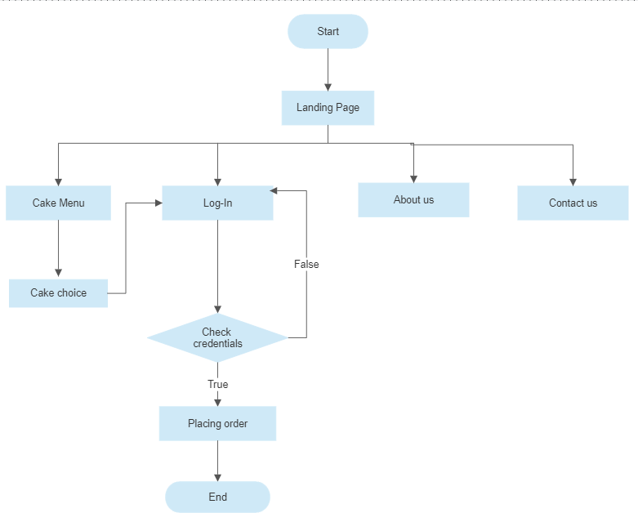

Figure 4.1 Web pages flow

When we initially visit the website, we are greeted by the landing page, which offers four options: our cakes, log in, about us, and contact us. If we choose our cakes, it will display a variety of cake designs or let us customize our cake. The final ordering process will begin after we are routed to the log-in page after choosing the cake design. To access our already designed cakes and place another order, we can also log in first. We thoroughly discussed our project in the "about us" section, and our contact information is provided in the "contact us" option.

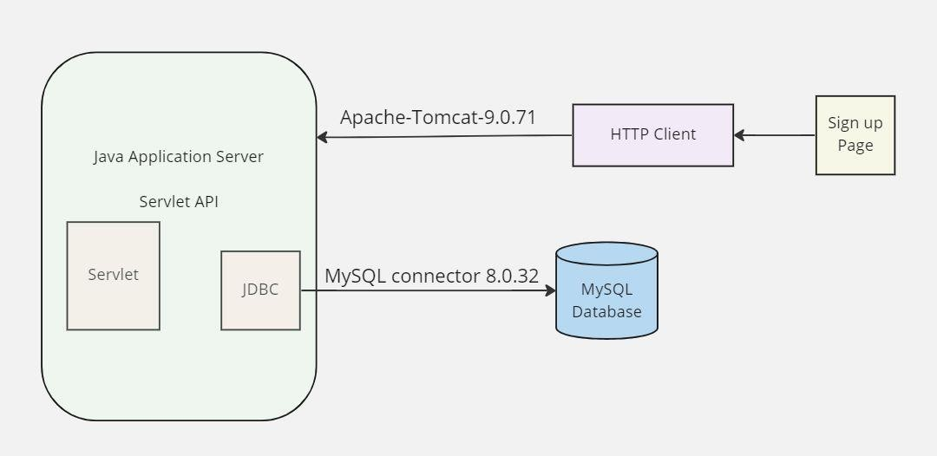

Figure 4.2 Connection of the servlet to the database

Before establishing a connection to the database, we need to load the JDBC driver that corresponds to the database we are using. The driver is typically provided by the database vendor and must be included in the class path of your application.

Once the driver is loaded, we can use it to establish a connection to the database. The connection object provides methods to execute SQL statements and retrieve results.

After the connection is established, we can create a statement object that represents an SQL statement to be executed. The statement can be either a query or an update statement.

Once the statement is created, we can execute it using one of the methods provided by the statement object. If the statement is a query, the method returns a ResultSet object that contains the results of the query.

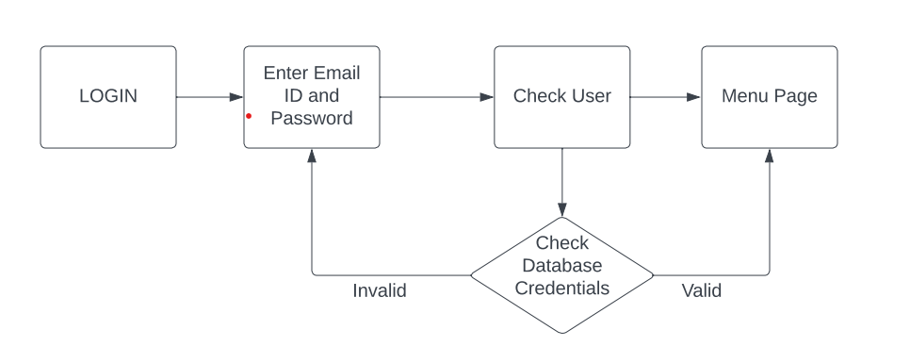

Figure 4.3 Login Page Validation

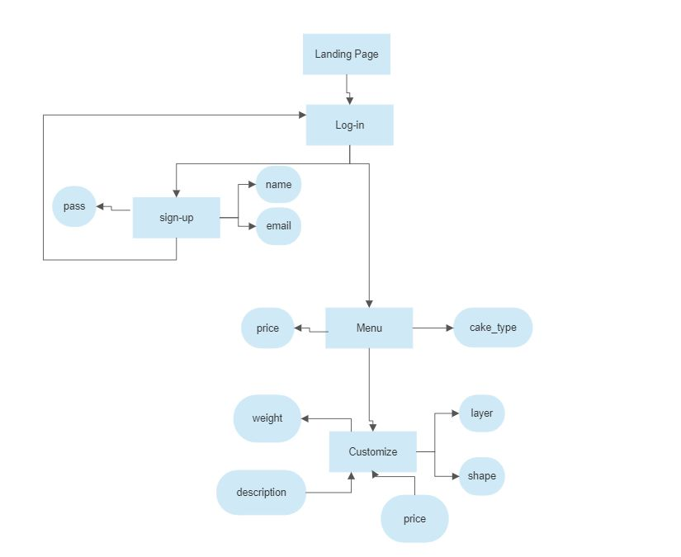Fig 4.3 shows the data flow diagram for Login page. When we enter our details in the login page, the email and password will be checked through the database credentials. If the details are valid then we will be directed to the menu page otherwise we will be directed back to the login page.

Figure 4.3 Login Page Validation

In the above figure(fig.), Entity Relationship diagram is given for our project's databases.The Sign-up entity has some attributes which are designed to store user details.

In the next step,if consumer place order from given menu it store the details in entity created for bill which store attributes like cake_type and price else if consumer goes for the customize option then on placing order another entity created for bill stores all the details given by user in various attributes like weight,layer,price or shape.

**CHAPTER 5**

**IMPLEMENTATION**

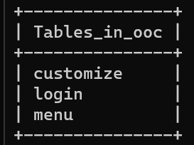

Fig 5.1 Database tables

Fig 5.1 shows the tables in our MySQL database. The name of the database is “ooc”. It contains three tables – login, customize and menu. Login tables stores the details that we give during registration. These details are used to check the Login credentials. “customize” and “menu” tables contains the order details.

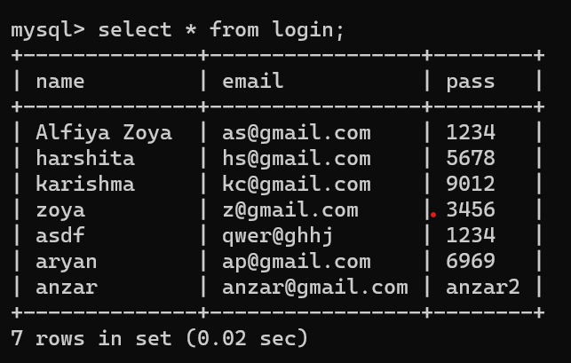

Fig 5.2 Database tables

Our webpage consists of a Login page connected through the database.



The flow of the login page is as follows –

Java servlet that handles a GET request. It uses JDBC to connect to a MySQL database and insert data into the "login" table. The servlet takes three parameters: "name", "email", and "passwd". It retrieves the values of these parameters from the HTTP request and uses them to create a new row in the "login" table. Finally, it redirects the user to home page.

The code first sets the content type of the response to "text/html" and retrieves the values of the "name", "email", and "passwd" parameters from the HTTP request. It then initializes the database connection parameters and creates a new instance of the JDBC driver class. It establishes a database connection using the driver manager and creates a new statement object to execute a SQL query. It creates a SQL query to insert the values of the "name", "email", and "passwd" parameters into the "login" table. It then creates a prepared statement object to execute the query with the parameter values bound to it. Finally, it executes the prepared statement and redirects the user to a login.html page. If any exceptions occur during the execution of the servlet, it prints an error message to the console.

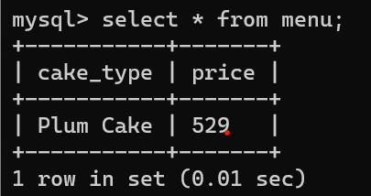

Fig 5.3 Database for pre-defined cakes

**CHAPTER 6**

**RESULTS**

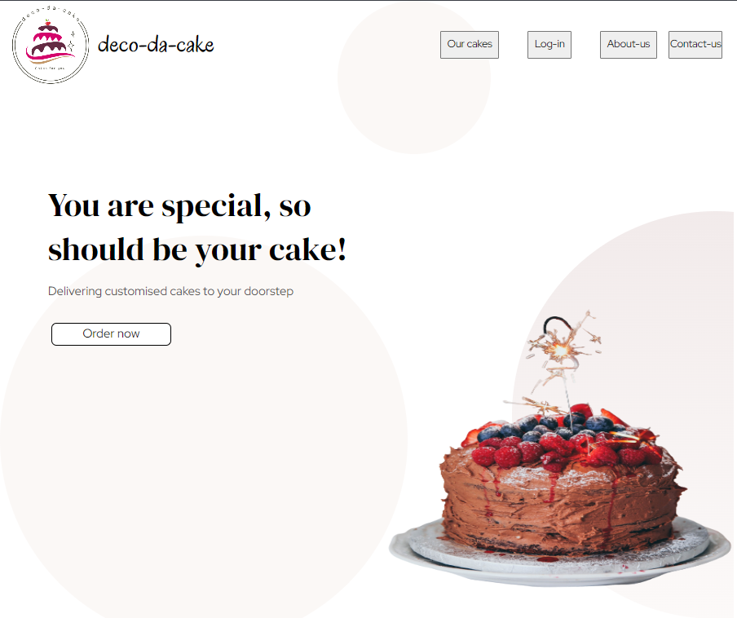

Figure 5.1 Landing Page

Figure 5.2 Cake choices

**CHAPTER 7**

**FUTURE SCOPE**

**Customization and personalization:** Customers appreciate the ability to customize and personalize their orders. Deco-Da-Cake can offer a variety of cake flavors, sizes, designs, and add-ons, as well as options for custom messages, images, and logos.

**Delivery and shipping:** Customers value convenience and flexibility when it comes to delivery. Deco-Da-Cake can offer multiple delivery options, including same-day, next-day, and scheduled delivery, as well as shipping to different locations. This can expand the customer base beyond the local area.

**Loyalty programs and rewards:** Repeat customers are valuable to any business. Deco-Da-Cake can offer loyalty programs, rewards, and discounts to incentivize customers to order again and refer friends and family.

**Social media and influencer marketing:** Social media is a powerful tool for promoting products and reaching new customers. Deco-Da-Cake can leverage social media platforms like Instagram, Facebook, and TikTok to showcase their cakes and engage with customers. They can also collaborate with influencers and bloggers to increase brand awareness.

**Diversification and expansion:** Deco-Da-Cake can explore diversifying their product offerings beyond cakes, such as cupcakes, cookies, and other desserts. They can also consider expanding their business to include catering services for events like weddings, birthdays, and corporate events.

**CHAPTER 8**

**CONCLUSION**

A cake ordering application where people can customize their own cake can offer a convenient and personalized experience for customers. By providing a wide range of cake designs and customization options, customers can create a cake that perfectly suits their tastes and preferences.

The development of such an application requires careful consideration of the requirements and user interface design, as well as the implementation of effective customization tools and testing to ensure the website functions properly. Additionally, collecting customer feedback and continuously improving the website can help ensure that it remains relevant and useful over time.

While there may be some drawbacks and challenges to developing a cake ordering application, such as the need to manage inventory and coordinate deliveries, the potential benefits in terms of customer satisfaction and business growth make it a worthwhile investment for bakeries and cake shops.

Overall, a cake ordering application that allows customers to customize their own cakes can offer a unique and engaging experience that sets a business apart from its competitors, and can help foster customer loyalty and growth in the long term.

**CHAPTER 9**

**REFERENCE**

[1] <http://www.fergusonplarre.com.au/>

[2] <https://www.dqcakes.com/>

[3] <https://www.bakerdays.com/>

[4] <https://joiv.org/index.php/joiv/article/download/82/53>